**DHARANEESH K**

**2014009**

**ALAGAPPA CHETTIAR GOVERNEMENT COLLEGE OF ENGINEERING AND TECHNOLOGY**

**DIGITAL MARKETING**

**PROJECT**

[**https://drive.google.com/file/d/16C4o0SFzghV4T-UhjRBZMaPy0zZKdEy2/view?usp=drive_link**](https://drive.google.com/file/d/16C4o0SFzghV4T-UhjRBZMaPy0zZKdEy2/view?usp=drive_link)

**ASSIGNMENT**

1. **Blog using Blogspot**

[**https://f00dl1.blogspot.com/2023/10/food-is-life-life-is-complex-tapestry.html**](https://f00dl1.blogspot.com/2023/10/food-is-life-life-is-complex-tapestry.html)

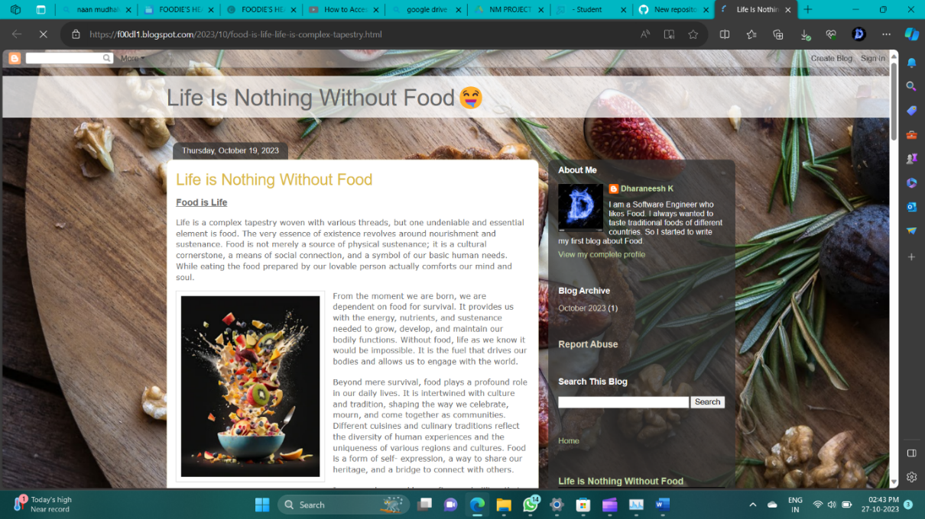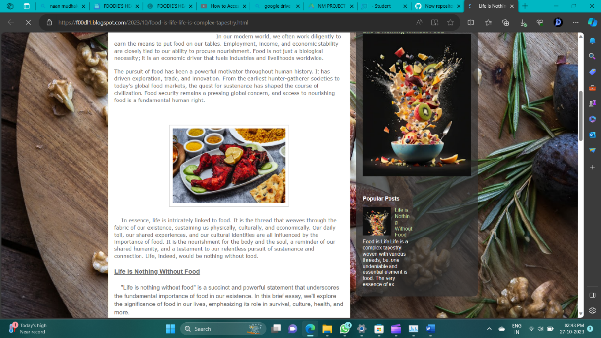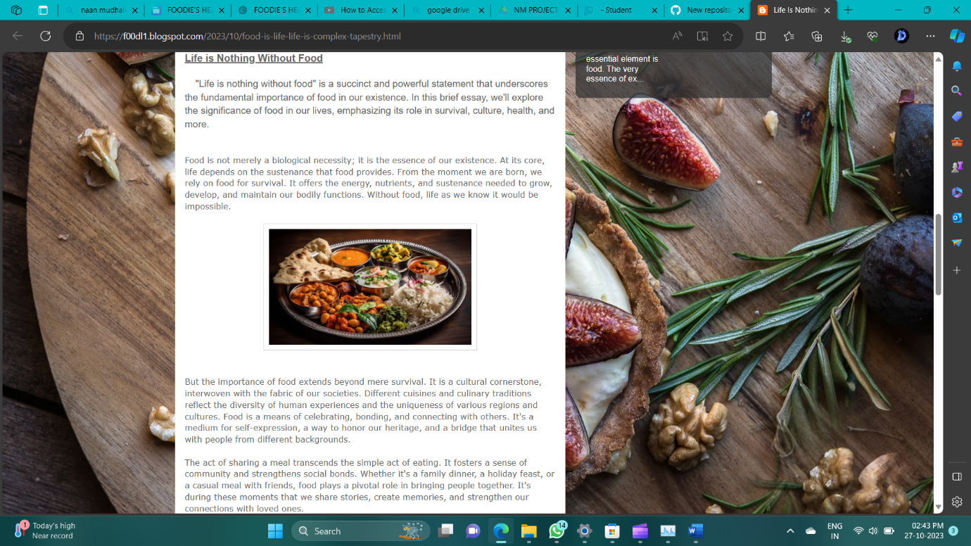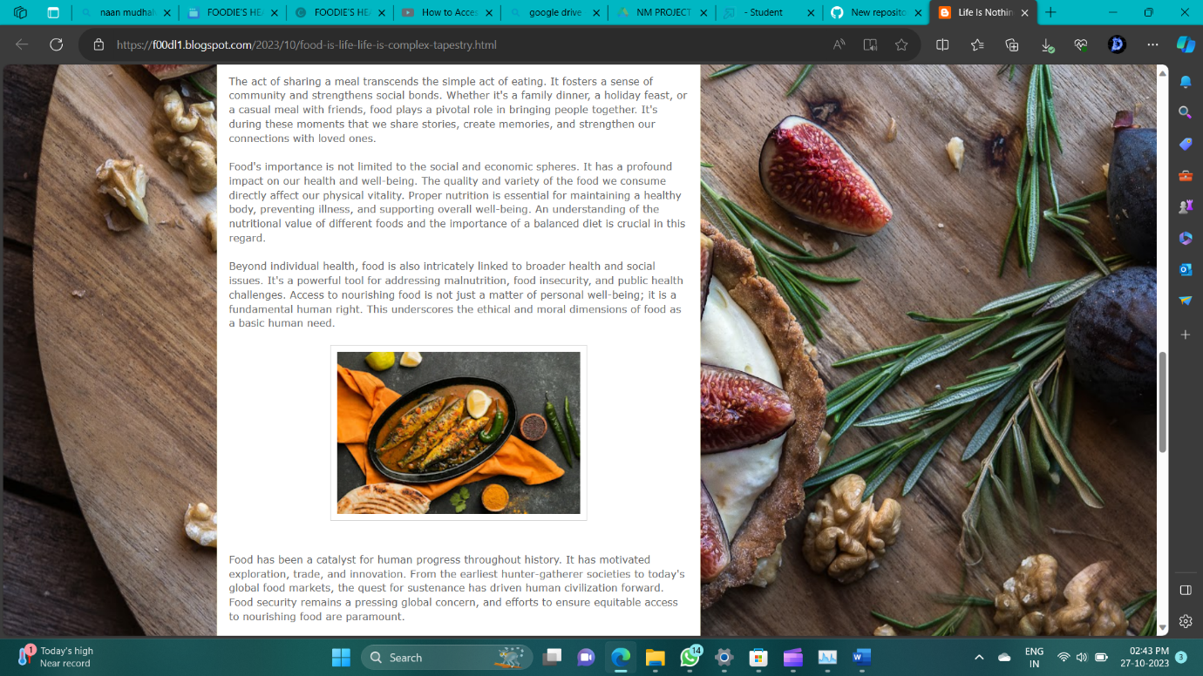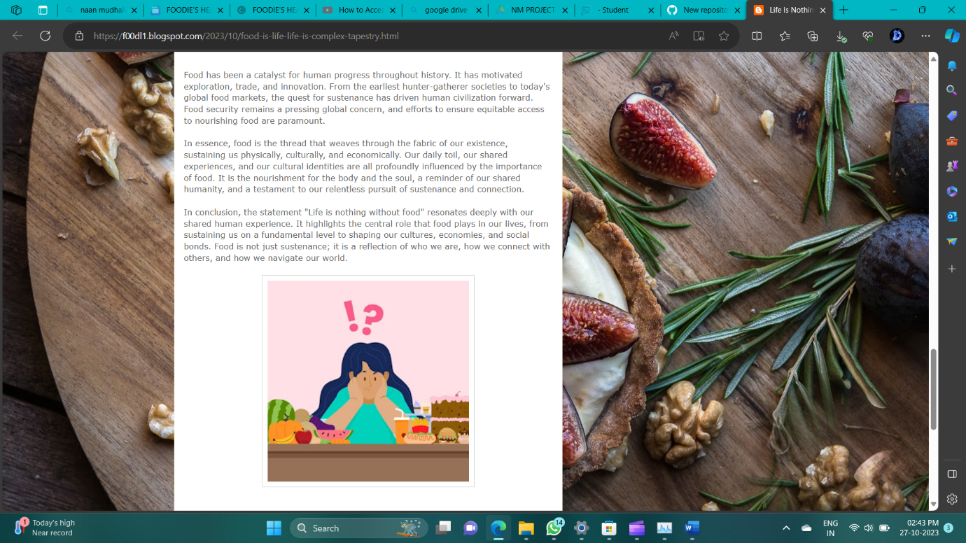

**2.Facebook business page and social media poster**

Created a Business page called Foodie’s Heaven and posted a social media poster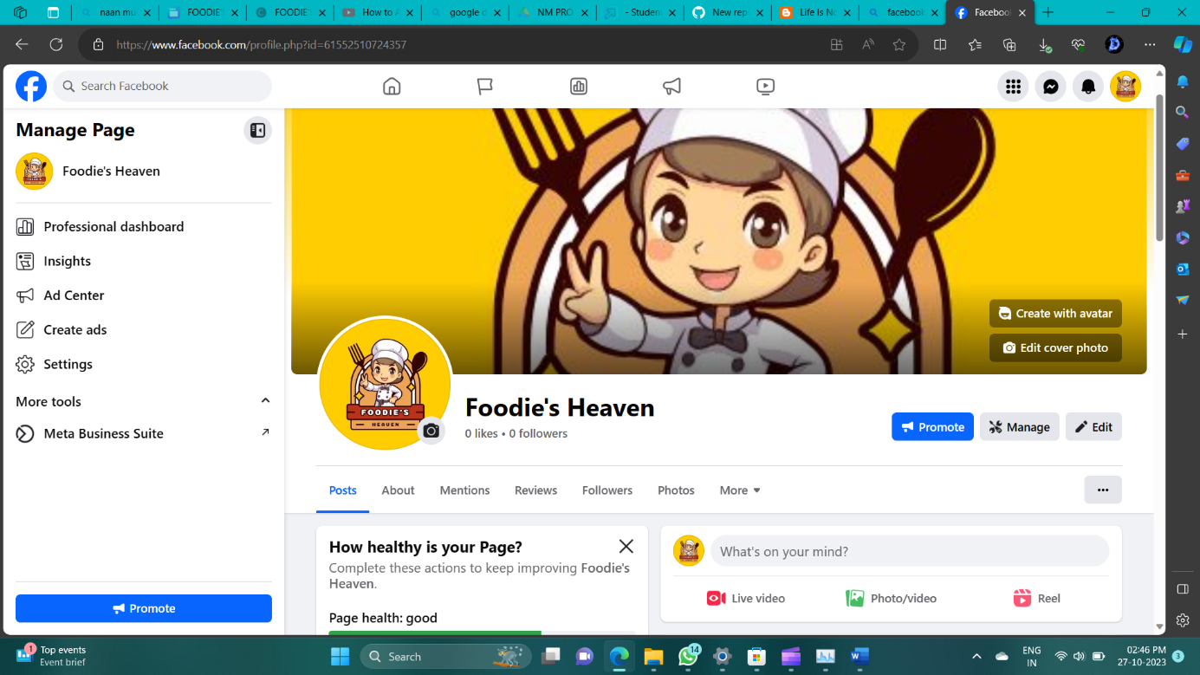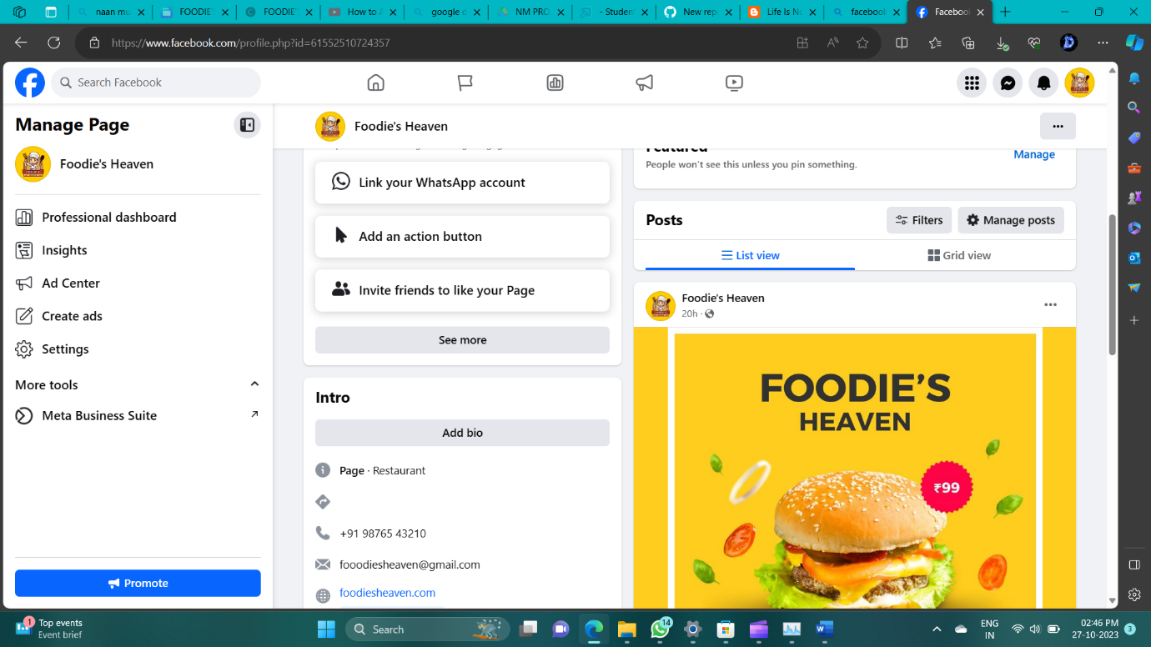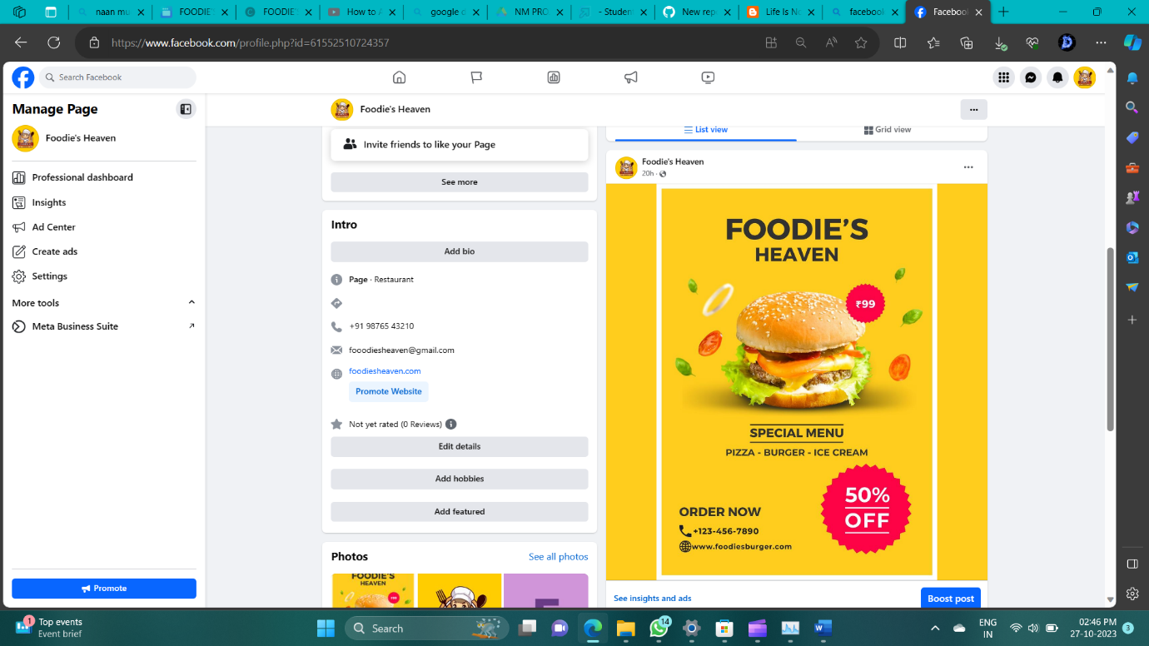

**3.Social Media Advertisement Poster using Canva**

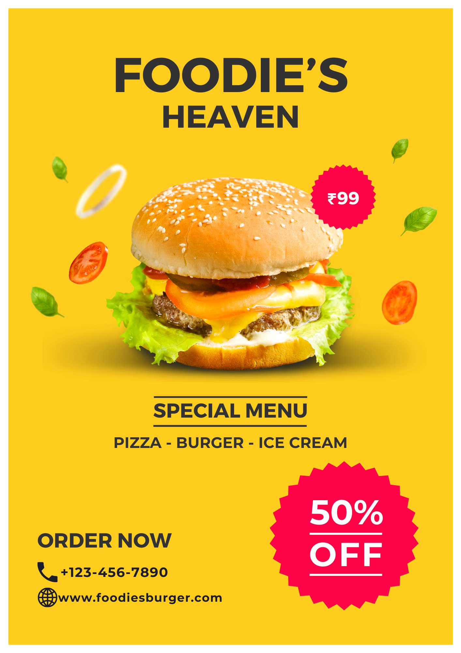

**4.Email newsletter**

[**https://drive.google.com/file/d/1ROgks5iiOgp1NtIGFf2QbKANcfud8OvF/view?usp=sharing**](https://drive.google.com/file/d/1ROgks5iiOgp1NtIGFf2QbKANcfud8OvF/view?usp=sharing)

